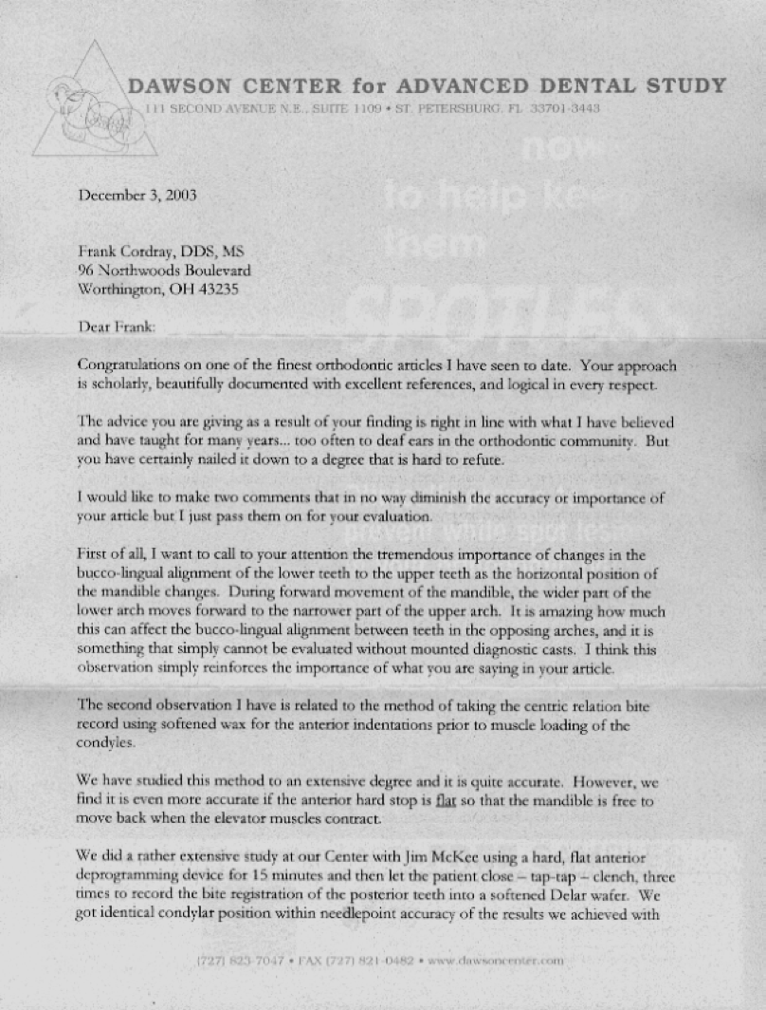

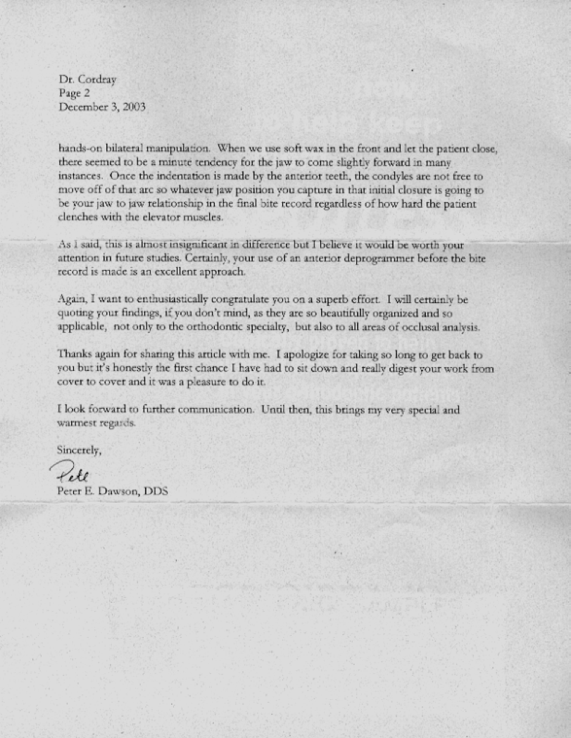

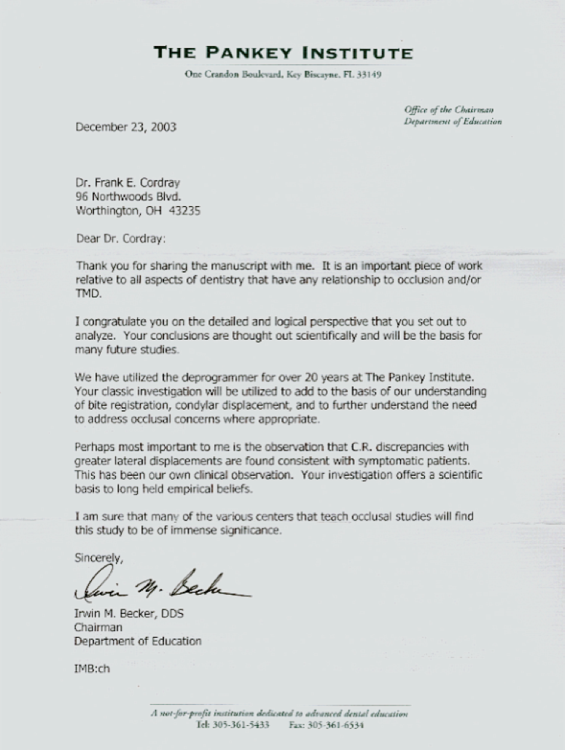

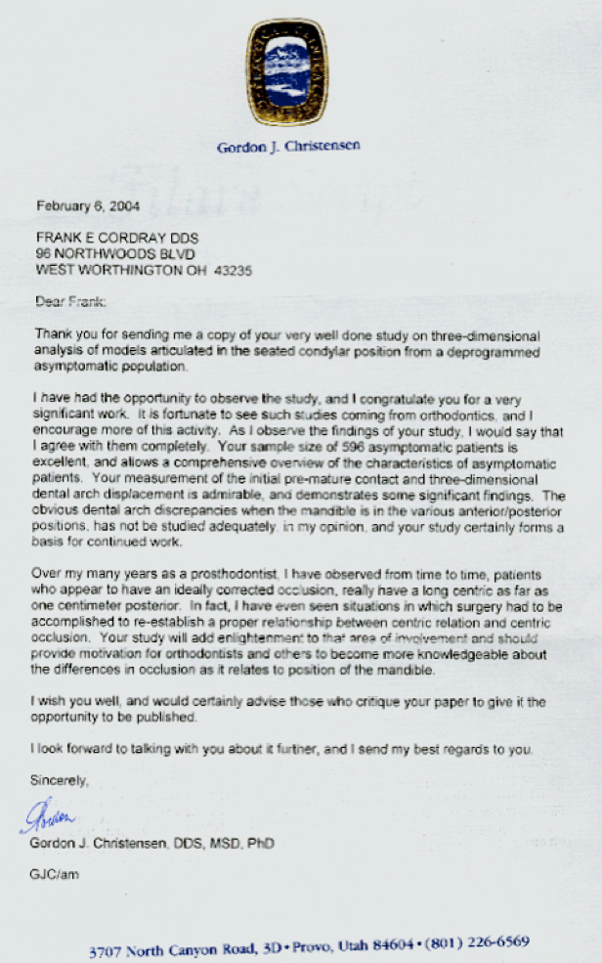

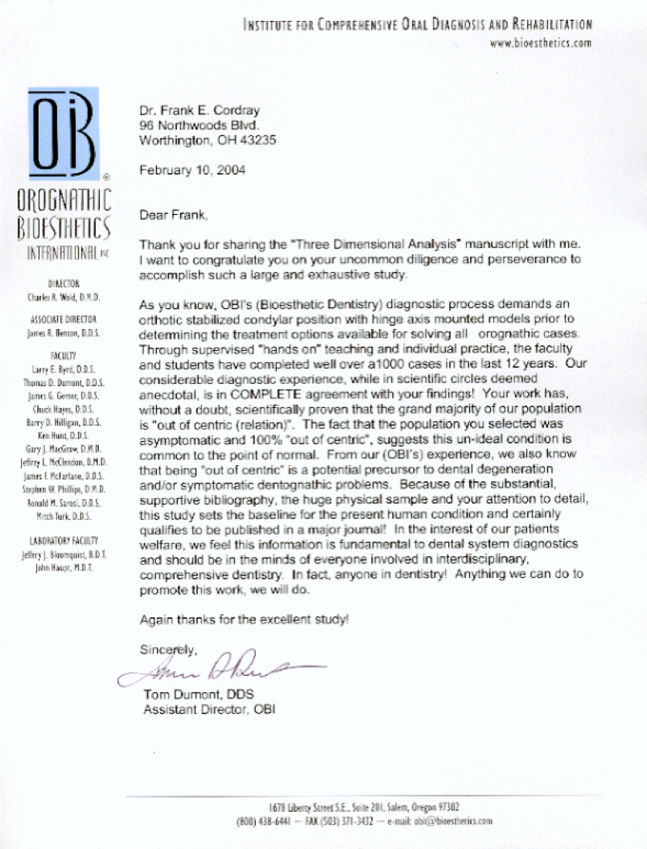

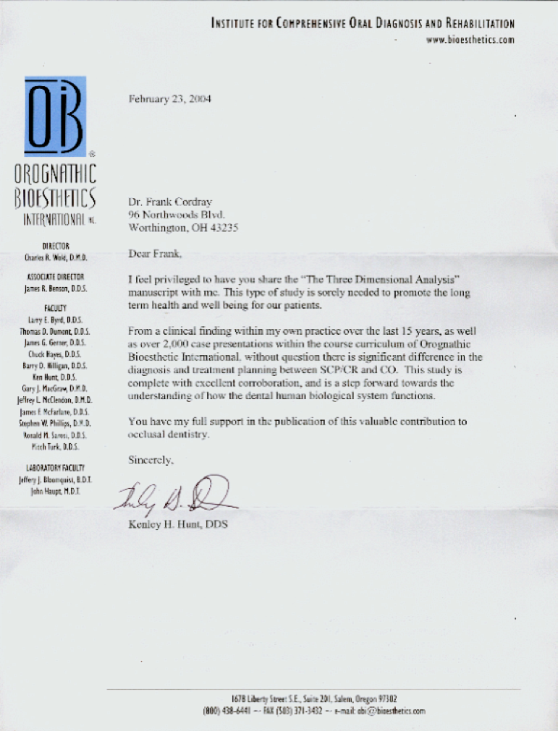

Supporting statements:

The following statements characterize the initial award-winning paper in this series (Cordray, FE. Three-dimensional analysis of models articulated in the seated condylar position from a deprogrammed asymptomatic population: a prospective study. Part 1. AJO-DO 2006;129(5):619-630):

Congratulations on one of the finest orthodontic research articles I have seen to date. Your approach is scholarly, beautifully documented with excellent references, and logical in every respect. The advice you are giving as a result of your findings is right in line with what I have taught for many years. I want to enthusiastically congratulate you on a superb effort. I will certainly be quoting your findings and including them in my new textbook, as they are so beautifully organized and so applicable, not only to the orthodontic specialty, but also to all areas of dental and occlusal (bite) analysis.

Dr. Pete Dawson, DDS, The Dawson Center for the Advancement of Dentistry

Your manuscript is an important piece of work relative to all aspects of dentistry that have any relationship to occlusion and/or TMD. I congratulate you on the detailed and logical perspective that you set out to analyze. Your conclusions are thought out scientifically and will be the basis for many future studies. Perhaps the most important observation is that mandibular condyle discrepancies with greater lateral displacement are found consistent with symptomatic subjects. Your investigation offers a scientific basis to long-held empirical beliefs. I am sure that the various centers that teach occlusion will find this study to be of immense importance.

Dr. Irwin Becker, DDS, The Pankey Institute

I want to congratulate you on a very significant work. Your study will add enlightenment to the area of occlusion and should provide motivation for orthodontists and others in the dental profession to become more knowledgeable about the differences in occlusion as it relates to the position of the mandible.

Dr. Gordon J. Christensen, DDS, MSD, PhD

It is with great pleasure that I nominate Dr. Frank Cordray for the 2007 ADA Gold Medal Award. His research paper addresses a very important topic for clinicians striving to improve their accuracy in diagnosis and treatment planning and overall treatment outcomes. Dr. Cordray's research elevates our profession by verifying the inter-relationships of the gnathic system (TM joints, teeth, skeleton, and face), thus adding value to our service.

Dr. Ron Good, DMD. MS

Your study is a step forward towards the understanding of how the dental human biological system functions.

Dr. Kenley Hunt, DDS, Orognathic Bioesthetics International

